PROJECT NAME: SPENDWISE

Team ID : SWTID-2026-1924
Team size : 5
Team Leader : YOGA ABIRAMI J
Team member : YAMUNA A
Team member : ANGEL HEPZIBA S
Team member : PRAJIN M
Team member : SHERIN PRINCY M

Spendwise:
- SpendWise – A Simple Backend Learning Project using Node.js
- Express, MongoDB, and JWT

Project Overview :
- SpendWise is a backend application designed to help beginner developers learn how to build secure REST APIs using Node.js, Express, MongoDB, and JWT authentication.
- The project focuses on implementing user authentication and basic CRUD operations in a clean and simple way so students can understand how backend systems work in real-world scenarios.
Key Objectives:
- Provide secure user authentication using JWT
- Enable basic CRUD operations on user data (transactions/records)
- Demonstrate MongoDB integration using Mongoose
- Show how protected routes work using middleware
- Maintain a simple and beginner-friendly backend architecture

Target Users:
- Beginner backend developers
- Students learning Node.js and Express
- Freshers preparing for technical interviews
- Anyone who wants a simple project to understand JWT and MongoDB
- Learners who want hands-on practice with REST
Project Instruction
npm init npm install npm run dev

Steps to Create the Project:
- Choose or create a directory for the backend project.
- Open terminal and navigate to that directory. ● Initialize Node.js project using npm init.
- Install required packages: express, mongoose, jsonwebtoken, bcrypt, cors, dotenv.
- Create folders: models, routes, controllers, middleware, config. ● Start the server using npm run dev.
- Test APIs using Postman or Thunder Client at http://localhost:5000.
Pre-requisites:
Software Requirements
Software | Purpose
Node.js | JavaScript runtime for backend
MongoDB | NoSQL database for data storage
npm | Package manager
Git | Version control system
Code Editor | VS Code or similar

Thumbnail for Project
• Node.js + Express + MongoDB + JWT + CRUD API

Technical Architecture
Backend Architecture (Node.js + Express)
- Controllers: Handle business logic for authentication and CRUD
- Models: Mongoose schemas for User and Transaction
- Routes: API endpoints for auth and CRUD operations
- Middleware: JWT verification and request protection
- Configuration: Database connection and environment variables

Database Architecture (MongoDB)
- Users Collection:
_id, name, email, password (hashed), createdAt
- Transactions Collection:
_id, userId (FK), title/description, amount/value, createdAt
- Relationship:
Many Transactions belong to One User

Roles and Responsibilities
Student / Developer:
- Write backend code
- Create APIs
- Test APIs using Postman/Thunder Client
- Push code to GitHub

System (Backend):
- Authenticate users using JWT
- Handle CRUD operations
- Store and fetch data from MongoDB
- Protect private routes

Users Flow:
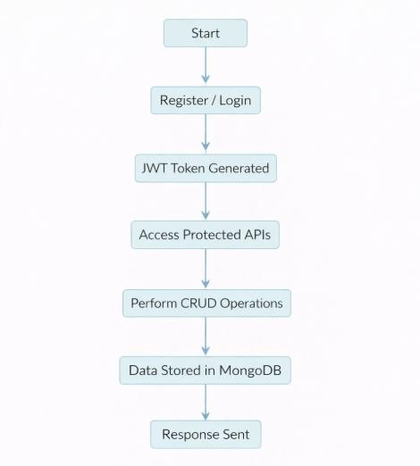

PROJECT SETUP AND CONFIGURATION

Folder Structure
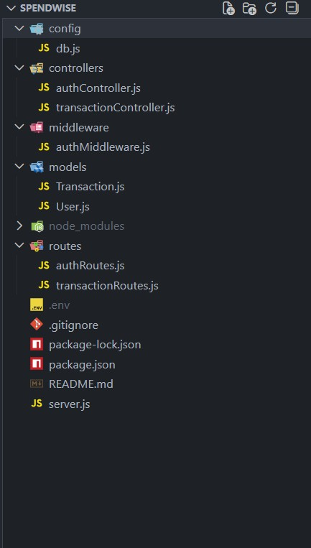

Project Setup
- Install required tools:
  - Node.js
  - MongoDB
- Create project folders:
  - server folders (models, routes, controllers, middleware, config)

- Install Backend Packages:
  - Express
  - Mongoose
  - Cors
  - Jsonwebtoken
  - Bcrypt
  - Dotenv

BACKEND DEVELOPMENT
- Setup Express server
- Create server.js file
- Create .env file and define PORT and DB URL
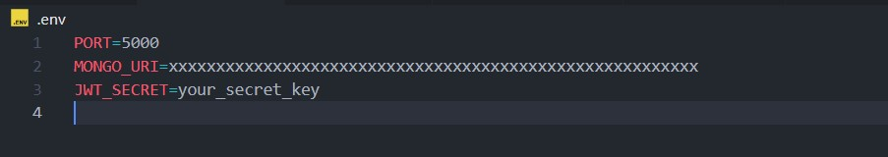
- Configure middleware (cors, express.json) ● User Authentication:
  - Create Register and Login routes
○ Generate JWT token
○ Protect routes using middleware

- Define API Routes:
  - Auth routes
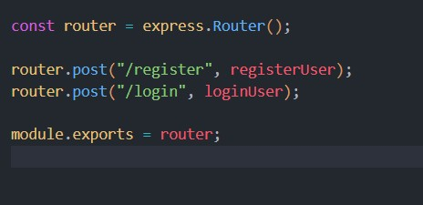
○ Transaction CRUD routes

- Implement Data Models:

  - User schema
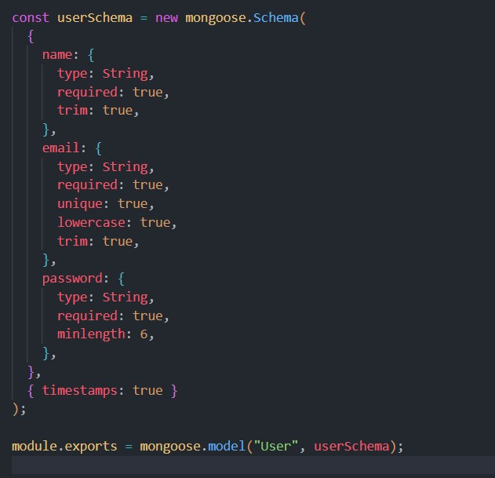

○ Transaction schema
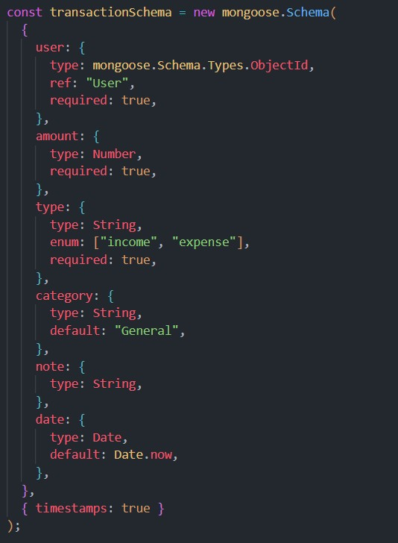

- Implement CRUD operations
- Add basic error handling

DATABASE DEVELOPMENT

Configure MongoDB
- Use MongoDB Atlas or local MongoDB
- Store connection URL in .env file
- Connect using Mongoose

Create Database Connection
- Create a config file for DB connection
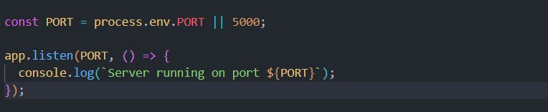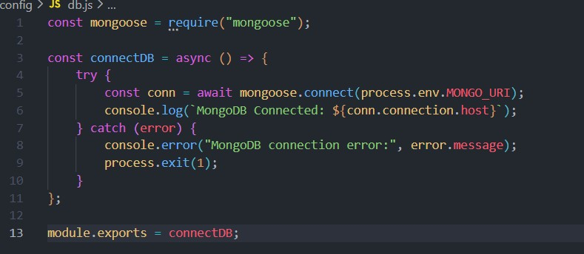
- Use mongoose.connect()
- Handle success and error cases

Create Schema and Models
User Model:
- Name
- email
- password

Data / Transaction Model:
- userId
- title / description
- amount / value
- timestamps

PROJECT EXECUTION
Project Execution Steps:
- Start MongoDB
- Run backend server
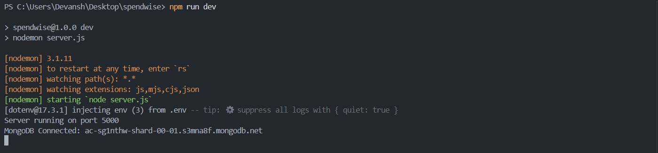

- Test Register API
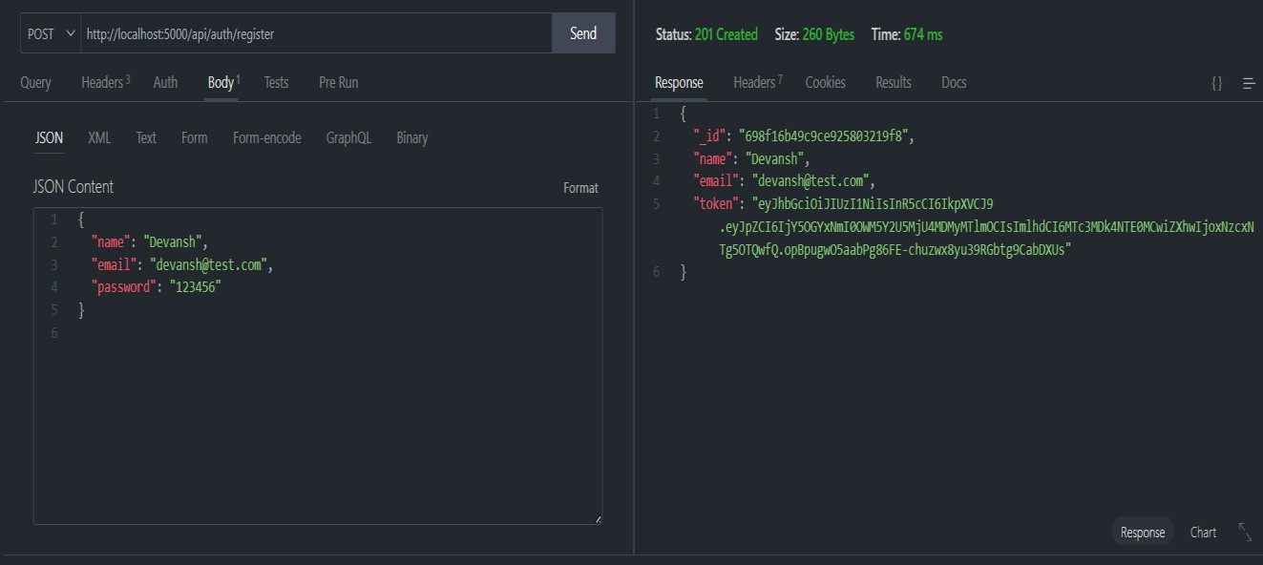

- Test Login API
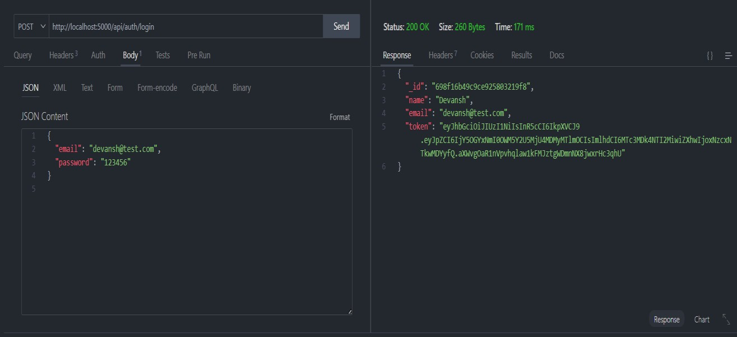

- Copy JWT token
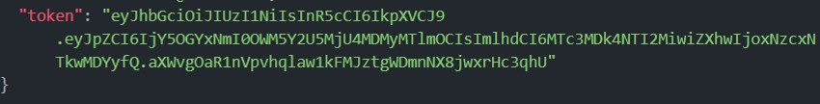
- Use token to access protected CRUD APIs
- Perform Create, Read, Update, Delete operations

OUTPUT SCREENSHOT

- Register API


- Login API


- Create Transaction
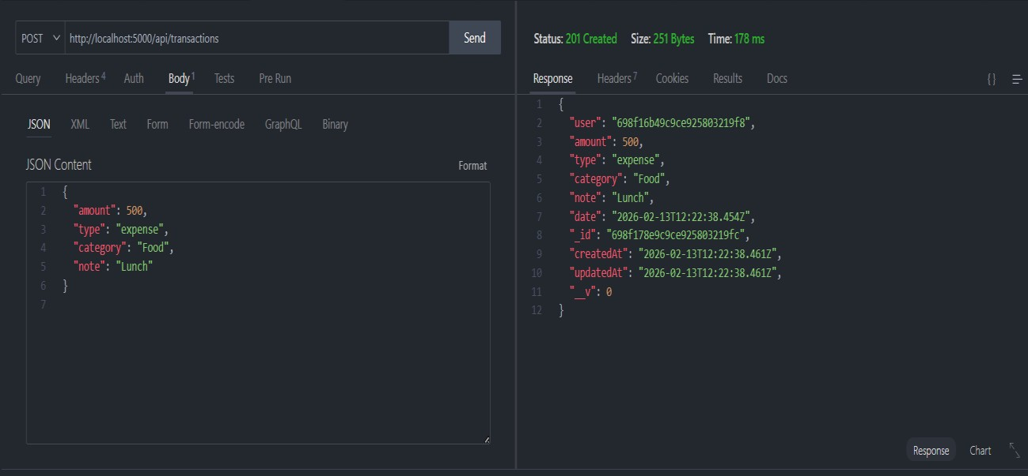

- Get information
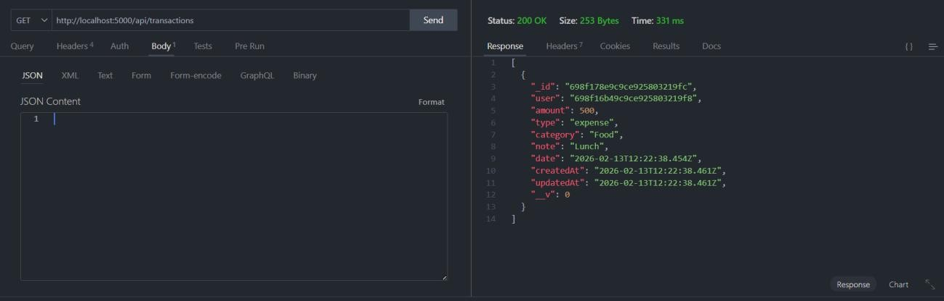

- Update API
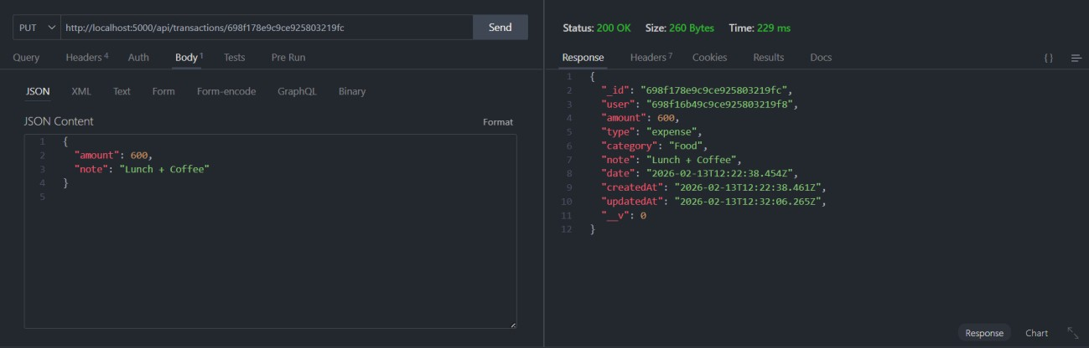

- Delete API
